    United Nations  Environment Programme | UNEP-GEF Project for  Building Capacity for Effective Participation in the Biosafety Clearing House | Global Environment  Facility

Biosafety Clearing House

UNEP-GEF BCH Project Training Materials & BCH Central Portal help system Integration Project

TOC Highlight plug-in
for HelpStudio

April 2008

Introduction
The aim of the document is to describe the TOC Highlight plug-in which was developed for HelpStudio during the project of building the OnLine Help System.

Problem
When a user enters the OnLine Help system from an external link (i.e. from the BCH), the content pane displays the content corresponding to the topic requested. However, the table of contents (TOC), in the left pane, does not show the current topic lies in the structure of the whole system. Therefore, the user has no means to know to which category of information the current topic belongs, and cannot browse for nearby units of information.

Figure 1 depicts this situation: the user has fallen into the “What is the Cartagena Protocol on Biosafety“ unit of information, but cannot see where in the tree structure it is contained.

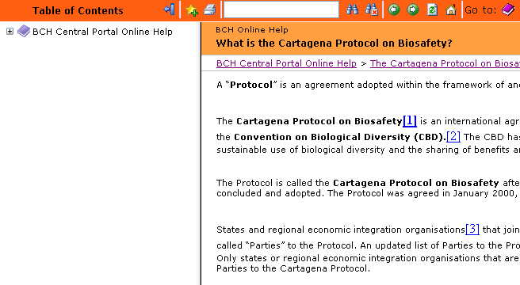
Figure 1

The desired behavior is that the tree view in the left is expanded so that the title of the unit of information is visible in the tree, and that it is highlighted with a different color.

Solution
A Javascript module was developed so that the online help always highlights the current topic in the table of contents, either if the user reaches the topic from an external link (using a URL of the form url_build/webframe.html?topic_name), or if the user reaches the topic by browsing manually from the root topic of the system.

The Javascript module (TOCHighlight.js) contains the necessary code to find the current topic (topic being shown) in the table of contents (TOC) and expand the TOC tree so that the entry corresponding to such topic is visible and highlighted with a background color.

However, for these features to be usable, it was necessary to add a piece of Javascript code into the webtoc.html and Standard.html files, which are generated by HelpStudio. These files are generated and overwritten each time the project is built, so the code added is lost, what means that this code needs to be manually reinserted into the files after every build. To avoid this problem, the code to be added was inserted into the HelpStudio templates for webtoc.html and Standard.html. Thus, this file is automatically generated with the Javascript modifications.

Figure 2 shows the results of entering to the same unit of information from an external link, in a system using the plug-in.

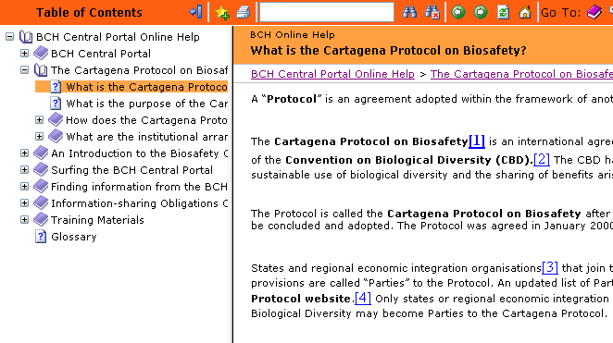
Figure 2

Implementation
The implementation of the solution required a thorough research of the javascript code generated by HelpStudio and the mechanisms used by helpstudio to implement the TOC, the structure of the html files, the use of templates, among other features.

The main javascript functions developed allow to search for a topic in the TOC given the topic name, to open the tree view so that the topic title is shown and to highlight the entry in the TOC with a different background color.

HelpStudio template files which were modified:
- webtoc.html
- Standard.html

Installation
A complete installation procedure was written with step-by-step instructions (DEV.PR.04. TOC Highligh plug-in). Once the plug-in is installed in HelpStudio, each subsequent build will have the features provided by the plug-in.

Compatibility
The plug-in has been tested for HelpStudio versions 3.5.0.22, 3.5.0.34, and 3.5.1.12.

